West Hull Ladies
RRC

January Newsletter

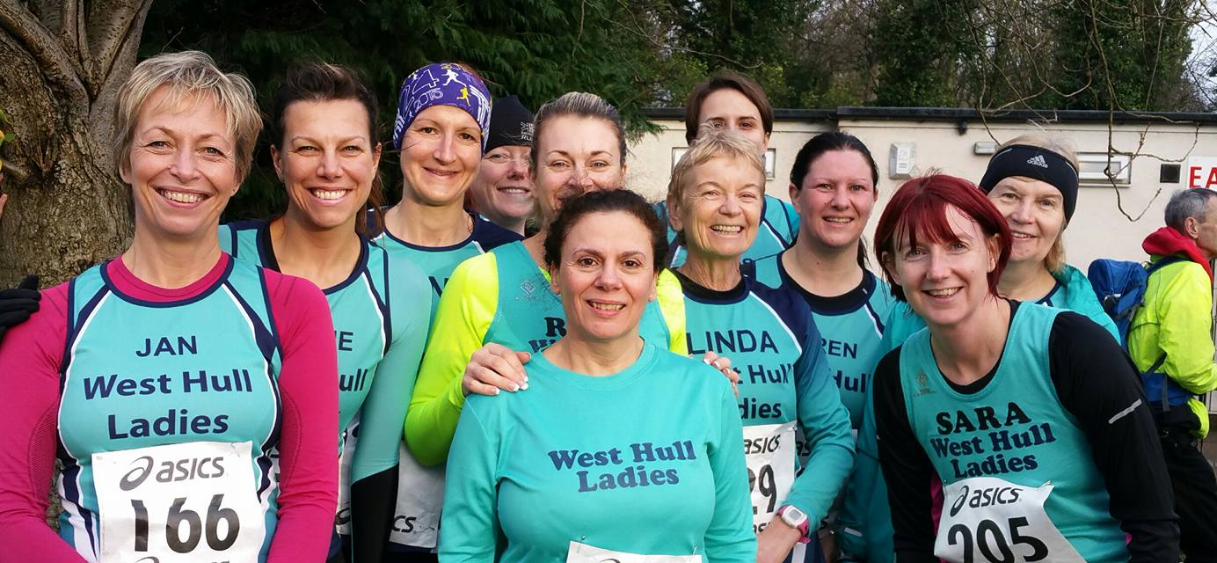

East Hull Harriers Boxing Day 10K

West Hull Ladies
WEST HULL LADIES RRC COMMITTEE MEETING
Committee Meeting 4th January 2016
Minutes
Present -Jill, Zoe, Sandra Amanda, Anna, Jan, Liz, Karen, Maria

- Apologies from Annette and Rachael L
- Minutes from previous meeting agreed
- Sandra updated that hoodies could now be purchased from pb teamwear. In relation to funding Liz was continuing with this. Amanda had as agreed contacted the organisers of Hull Marathon about our willingness to help with drink station and goody bag filling at the marathon in 2016. See item 6 for presentation evening. Jill confirmed she had sent out email asking for ladies views on underwear for running. The results would be in the forthcoming Newsletter.
- Amanda updated the group about the 0-5k course. 16 ladies had signed up and probably more were interested. Tonight had been the first night and it was well attended by members of WHL and new runners. Amanda informed the Committee of all the hard work undertake by Annette in relation to this. The Committee wished to express thanks to Annette for all her hard work.
- AGM - It was agreed that this could take place on 7th March 2016. Jill as chair to circulate details of all officers’ posts and ask for any nominations. Action Jill to email members.
- Presentation evening. Jan to liaise with Back Room to see if 12th March was available. Jill to email members in relation to awards where they had a vote and to work with Linda on purchasing the awards. Action Jill to email members about awards. Jan to contact Back room with new date.
- A short discussion took place concerning ladies training on a Wednesday with City of Hull. This training was beneficial to the ladies and as a Club we wished to thank City of Hull for their support of WHL. To be further discussed at AGM.

Meet a Member- Maria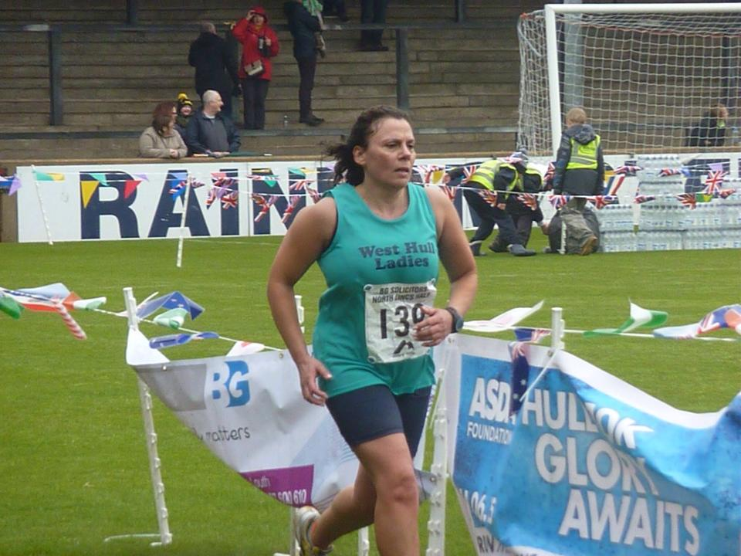

Name Maria Diaz

Age 52

Member of WHL since – February 2011. This was one of my best decisions in my life.

What do you do when you’re not running? – Not running??? I seem to be always training for one race or another so running is most of what I do with my spare time, well that is what my family think but I am sure they exaggerate. I work full time; I also volunteer one evening a week at Costello as a Sports Coach with kids 8 to 13.

How long have you been running? –I started running when I lived in London a few years ago but only managed about 8 months due to the Achilles problem; I started properly again when I joined WHL.

Why did you start running? – I started just to keep fit but now it’s an obsession, I think of nothing else, I know most of you will understand what I am talking about.

Favourite distance – 2 yards! Well anything over 10k as I find short distances tougher because I have to run a lot faster than I’m capable of.

Favourite bit of running kit – Thermal skins, they really keep your legs warm when it’s bitterly cold.

Any injuries? – Where do I start? Permanent achilles issue but I see a physio once an month and get fixed to keep running, IT band has its moments mostly when I am doing a race that is about half a marathon and it starts playing up on the first mile, after that I just limp most of the race.

Running goals? – Marathon, but it still scares me having to run for about 5 hours so not quite decided yet if I will do one.

Proudest moment running related or otherwise – Personally my grandson, he is just the cutest thing ever, running will be doing the 24 hour thunder run in 2015, I did 4X10k laps but the last one almost did not happen as the one I did during the night with the head torch was a total disaster, it took a lot of will power to set off on the 4th lap as it was raining and I knew the course was going to be a mud slide.

Best piece of advice you’ve received – Keep running………

Running alone or with friends? – With WHL friends, always nice to catch up with every one, could not imagine ever running without you.

What keeps you motivated? – Trying to get faster, so pb’s on all distances.

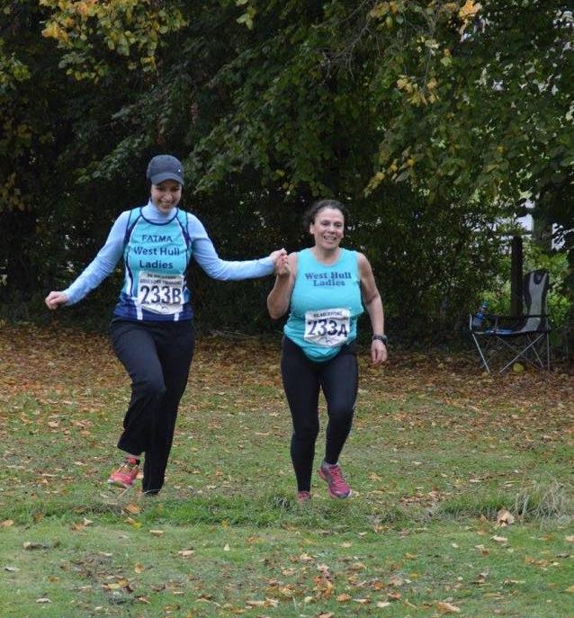

Auld Lang Syne Fell Race, 31st Dec 2015: Amanda
.

My friend Becky encouraged me to join her for this race. She is a fell runner and member of Bingley Harriers. On the day, neither of us were on top form. I had been unwell and felt under par whilst Becky had an Achilles injury
Fell Running Association description of the event is:
FRA BS (cat B, short length) fell race - 9.6km/300m from Penistone Hill Country Park, near Haworth, W Yorks (GR 025364)

The cat B and short length meant we did not have to carry water proof, map compass etc. and it certainly did not feel like a serious undertaken as fairies, strong men, elves and imps lined up to race. The distance is 9.6KM with 300M of climbing and along with a good splattering of mud it was not going to be a fast time.

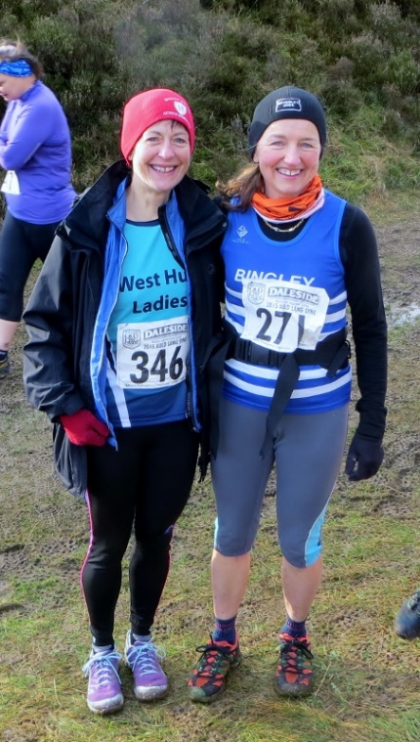

Lined up at the start, the mud beckons:
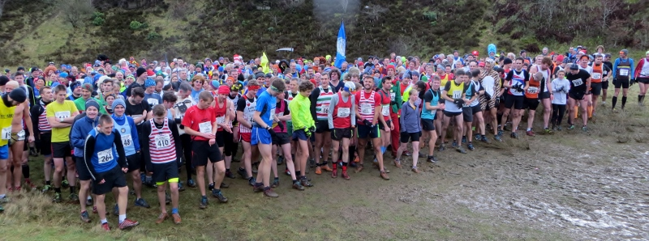
So there we were mostly sensibly dressed. It was 4C with a wind chill dropping it to -4C and a little way in front of me was the guy in his underpants and trainers carrying his strong man bar!!!
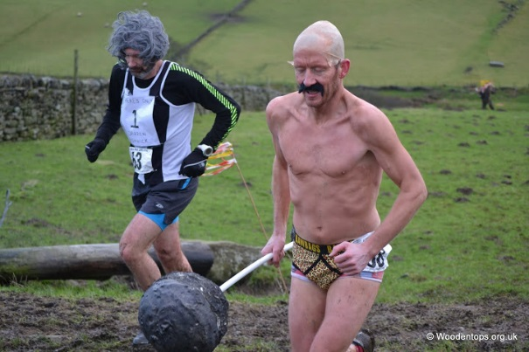
The first part was a little muddy then we were onto track which was fine. I steadied into an uphill chug and passed my friend Becky. We climbed for a while then down a field to the stream crossing. Took this steady. It was less than a foot deep but slippery stones. Then steeply up a field before back on track. Quite a long drag into head wind. Eventually could see runners along the ridge which loops round to the track for the return. It was great to see the front runners hammering back down. Once on the ridge we were on a single track, peaty path, rough either side. I decided that passing people was too tricky and I would probably twist an ankle or annoy someone but this is where Becky’s fell running experience kicked in. She passed me and several others before we were back on the track.
Turning at the trig point, Becky ahead.
Note, the ribbons. The route was well marked with marshals in strategic places:

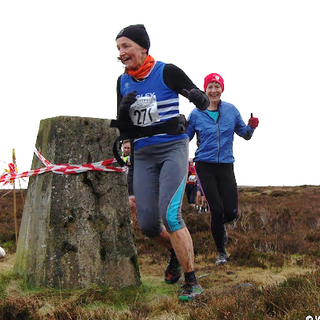
Back on the track and I enjoyed getting back into a good rhythm though the terrain behind was much more interesting.

The field to the stream was a mud bath but I kept my feet then it was up the field where there were quite a few spectators. Someone shouted “Come on West Hull” and “Bet you don’t get this in Hull” to which I responded “You bet. No mud in Hull!” Onto the track but I suddenly felt quite drained. Nearly home when hit by a leg sapping section where the path snaked through a peat bog. Felt I was going backward. It was a relief to reach the track through the car park then a final grassy section before hitting a very steep, short drop which apparently the front runners bounded over touching one foot before bouncing onto the flat. Mine was more of a ‘ooer, yikes, scramble, totter, phew’ before reaching flat ground for the final 10 metres into the finish funnel.

No chance of a prize as lots of great runners and prizes are in 10 year categories. The first FV50 ran it in 62:54. Becky came 6th in 67:01 and I was 7th in 67:29. It was a great, but tough run. Enjoyed it and a great way to see 2015 out. Maybe another one to put on the calendar to see 2016 out.

If interested, take a look at the event photos Some fabulous costumes.
http://www.woodentops.org.uk/index.php?topic=als

Runners Brain by Linda

I’m talking about what our ‘brains’ think about whenever we run. Here’s a taster of what goes on in my head!
I started training with WHL in June a couple of years ago after ‘jogging’ on my own and daring to enter two local 10k’s and seeing all those lovely coloured vests, I wanted to be a part of you but was I good enough?
First session Hill Training with Amanda. Having it explained to me I thought the idea was to just run until you got to the top of the hill then you could stop and die.

Amanda:’ Keep going Linda, why have you stopped, are you ok?’
Brain’: Because she can’t breathe, her legs are wobbling all over the place and you want her to keep going? Totally impossible, when can she go home to my nice tea and shower?’

So after a few weeks of running with you all, I thought I needed to keep up with some of the faster ladies, what a good idea.

Brain: ‘Run behind Sara and Rachael and keep up with them. Help they’re going too fast, you can do this, flipping ‘eck they are chatting like they are sat in a coffee shop, hell they never stop, how are they doing this? You’re never going to be able to do this, have we nearly finished, what still another 3 miles to go! You’re surely going to die!’

First serious race, Ferriby 10 on a cold, wet, windy day. Only two WHL entered me and Adrianna.

Brain:’ You’re so stupid, look at the weather, you’ll catch your death’. Me:’ Go away, I’m going to be fine, I know I’m shivering and I have a coat on soon I’m going to have to take it off and stand with all those other stupid people and hell, run.’ Brain’: And she’s off, why won’t she listen to me, oh boy it’s hilly, where did the hills come from, look at the rain and sleet horizontal, she’s mad, why won’t she listen. Oh look there’s a woman running towards her, stupid woman surely she isn’t just training in this she could wait until the rain stops, oh wait it’s Amanda, what’s she doing? Oh boy she’s cheering her along, another mad person! What;s she saying, keep it up you are headed for a sub 90min. Hell what’s 90min and how long is that ,Amanda is talking,’ Come on Linda you can do it just 15 mins from the end.’ 15mins from the end oh boy that’s a long time (I think), another 15mins in this horrid weather, will it ever end. Oh good she’s run off. Why did she take up running, this is stupid she could be home in the warm drinking hot tea. She’s never running again, throw away those trainers buy high heels instead. Oh look the finish, about bloody time, why is she crying. I can’t believe it she said she enjoyed it but will be glad to get home and dry.’

Brain: Oh no there she goes on the computer entering another blinking race, will she ever learn.

Brain: ‘She’s only gone and entered a marathon, OMG this will be the finish of her (and me)! Here we go, training, running miles, and miles, and miles, no other thoughts in her head but running kit, food, keeping well, marathon, marathon, marathon! Oh boy will she ever learn.’

Brain: ‘Ok here it is the big day, she’s nervous, how many times does she really need the loo? And she’s off. Talking to herself, yes I know you’re going to take it steady, heard it all before. It’s chilly, it’s tough and you’re getting tired.’ Me’: Shut up brain, I can do this so just shut up’. Brain: ‘It’s mile 18, that’s enough now you can see you’re tired, think I might shut down all this jiggling up and down is no good for me. Just STOP.’ Me:’ I’ve told you I can do this and I will so go away and get outta my head!’ Brain: ‘ Ok, anything for a bit of peace. What’s that she muttered only a 10k to go, does she know how far that is? It’s a bloody long way, like over 6 miles, ok a bit nearer now only another 3 miles to go, 3 miles that’s going to take forever. Just over a mile to go, hell she’s thinking that’s only like running to West Bulls, not far, what’s she doing these feet can’t go much further doesn’t she know she needs to STOP! Oh look just up the Hill (who the hell put a hill there at the finish, stupid man), nearly at the finish, just a little way to go, oh no it’s further than you think, ok breathe deep, yes you made it’. Me: ‘No thanks to you brain.’ Brain: ‘Stop crying you know you loved it, what no more marathons, good.’

Brain:’ Oh no what can I see, she’s doing it again on that darned computer entered another marathon! She’s not going to put me through that again is she?’

Brain: ‘What’s this? Some new form of training, track! This looks different. Warm up and chatting, seems like fun, this is easy I’m going to enjoy this. What’s that the coach said? 800m, 600m x3 then 200m x5. Ok sounds like fun. Oh no what’s happening they are all running faster than you, you can do this. What are you doing, I think you should slow down, no you’re trying to go faster, wait you can’t breathe your legs are screaming at me to stop but you don’t, what do you mean shut up only 200m left? You did it, what you are doing it again, you haven’t got your breath back. That’s it just follow the girl in front of you, copy her stride pattern and make sure your feet plant on the ground the same time hers does, why isn’t this working, why is she getting ahead of you, go on you can do this try harder. That’s it you’re catching up. Phew it’s finally over, take that smile off your face, no you did not enjoy it what are you saying, the same next week, you must be mad!’

........ And I’m sure all your ‘brains’ talk to you in much the same manner, if they don’t they you’d better send off for the yellow van to come and take me away!

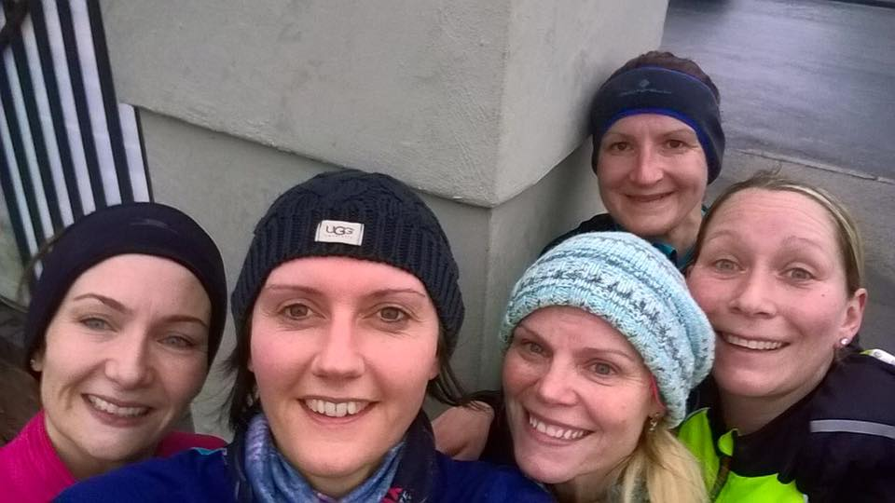

Running with the 'right' underwear!

A few months ago I thought it might be a good idea to write an article that collated people’s thoughts and experiences about the ‘right’ sort of running underwear plus their underwear experiences. This is not because I have a kinky obsession about running underwear, but because getting it wrong can be at best an uncomfortable experience, and at worse can really put people off running for life! As Jan says:
“I have in the past had bad chafing after long runs typically at the lower back/knicker line margin and under my bra at the front. The trouble is that when you are running you don’t always know that the damage is being done – it’s often only when you get in the shower afterwards and the ‘ouch’ as the water hits the skin tells you that you have a problem!”
Of course there is no simple answer to what is the ‘right’ underwear for any one particular person, as you will see from this article, as this is very much a personal choice, but other people’s experiences can help others make a more informed choice. This article therefore will look at running bra’s, knickers and socks, plus some issues related to these, so I hope you will find this interesting.

Running Bras:
I always run in Shock Absorber running Bra’s, they are absolutely awesome in my view. I have in the past, run in Debenhams ‘Gorgeous’ sports bra’s, which are not bad, but I’ve run marathons and beyond in the ‘Shock Absorber Ultimate run bra’ and have never chafed or felt uncomfortable. Shock Absorber also do a general sports bra and an unwired sports bra, which I’ve used and are okay, but the one I like is the ultimate run bra. An added advantage to this bra is that you can swim in it. This is because it is made of quick drying materials, which wick any water or sweat away from your skin. Why would you want to do this you might ask? Well if you ever want to do a triathlon, and are quite well endowed, the pathetic integral bras in the majority of tri suits are just not up to the job when you have to do the run. Tri suits are not the most flattering item of clothing anyway and without a decent bra underneath, could certainly result in some major photo fails!
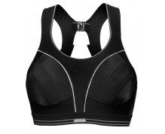

Jan Draper also swears by Shock Absorber bras:
“I wear the Shock Absorber running bra and don’t run in anything else. I am reasonably well-endowed in the bosom department so it’s really important to limit any stretching of the Cooper’s ligament to avoid (even) droopier boobs in older age. So I never ever go out without my Shock Absorber on. I have about 4 now so that they can be in various stages of the washing cycle too. And multiple copies are important for events such as Endure 24 and Thunder Run”.

Lynne however endorses ‘the Reebok high impact sports bra’ which she bought in the States, which has been successful for both her marathon exploits and doing the 24 miles of the Rudolph Romp.
Linda’s advice is that the main thing should be that a bra should fit well. Whilst this may seem obvious, many women underestimate their Bra cup size, and sizes may not necessarily be consistent between the different makes.
“Bra's I have no problems with so long as it's a good fitting sports bra and one you're comfortable with while out on runs. Even small breasted ladies need a good fitting sports bra as it is very uncomfortable to have any parts of your boobs bouncing up and down, yes even us small ladies. But I was a bigger busted lady in my past life and even then I hated them bouncing up and down so a very good fitting heavy duty bra is a must as those muscles sure don't want to be damaged in any way”.

A good running bra may be expensive, but is a worthwhile investment, and you might be able to get some good deals from the internet. Zoe suggests that you should be cheeky and go to somewhere like Debenhams and try a few on for size, before buying from the internet.

Running Knickers:
Whilst it may seem okay to just use any comfortable knickers, (and some people would advocate wearing your running tights or shorts with no knickers at all) you will find that specialist sports knickers are made of materials that wick away any moisture and sweat. With all running clothes this is an important issue as it both prevents chafing and stops you getting cold, if you get wet in the rain. I was intrigued to find out that you could actually purchase a ‘Running Thong’ but I don’t know anyone who has endorsed such an item. I personally quite like the ‘More Mile running knickers’. They are relatively cheap, (around a fiver) and I have found them to be really comfortable for all the long races I have done, plus they do not chafe even when it chucks it down with rain. Lynne likes her trusted Lonsdale sports knickers from Sports Direct, which she also says have never chafed or caused any problems in any of the running or racing that she has done.

Linda has had some ‘knicker fails’ in the past but has now found a solution:
“As for knickers! Well I've had a fair few horrid runs with the darned things getting stuck which is horrid and very uncomfortable. I have also had some comfy ones but by the end of a long run they have become very damp with sweat and have been horrid against your skin and by the time they get to this state they chafe and make you sore in places you certainly don't want to be sore.

I have finally invested in some excellent ones and have tested them on long runs, speed sessions and our normal type training 5/6 miles. They were great for the Rudolph and I was running for over 5 hours and they stayed dry and I was comfortable. They aren't cheap but if you only use them for runs they will last you oh and don't use the dryer on them either I just dry them on an airer. They are from Runderwear and have been designed in Britain although made in China. I know I won't be wearing anything else in future”.
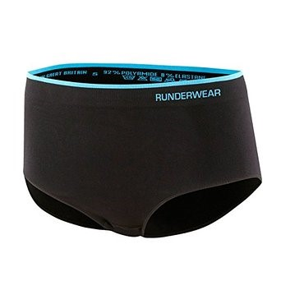
Jan also has some advice about this issue:
“Knickers I have found to be rather a trickier affair! I have experimented with ‘ordinary’ big knickers but these don’t work for me. They either ride up or rub and are not comfortable. And also they don’t have wicking properties. I discovered Odlo women’s running knickers (boxer type style) a few years ago and have run with them ever since. They are expensive – about £25 – but are worth their weight in gold. They are comfortable to wear when running and wick moisture away”.

Running Socks:
There are so many options with socks and this section reflects this choice. Some people are able to wear just about any socks without mishap yet for others; the choice of socks is crucial. Lynne likes her Nike blister socks from Sports Direct; Linda likes the sports socks from Aldi or Lidl:
“Socks, well I tried all sorts even the most expensive fancy blister free type (which gave me blisters) and the best I've found are those you get from Aldi or Lidl for around £1.99, they don't last long but neither do the more expensive ones so when they have them I buy loads. I have never had blisters since wearing these wonderful cheap and cheerful socks and again I used a pair on the 24 mile Rudolph without any mishaps. (Although they were a bit muddy and wet and smelly at the end)!!”

For me socks are the bane of my life. The reason being, that I have been so prone to getting blisters, losing toe nails etc. when doing longer races (Don’t let this put you off though as it really isn’t as bad as it sounds!). I also have some varicose veins on my legs which tend to result in my right ankle swelling if I wear socks that constrict the area, and to cap it all…I have a bunion on my right foot which makes my big toe, run into my other toes (Maybe I should take up knitting instead of running!). As a result I have probably tried almost every sock option there is, and tend to change my mind depending on how I feel at the time! Because I tended to be prone to calf injuries when I first started running, I now always run in either knee length compression socks or calf sleeves, which are supposed to help stop injuries and/or aid recovery. I like the ‘1000 mile compression socks’, and these have mostly served me well, although it is very important in a long race, to make sure that you do not pull your socks on too tightly and conversely that you get your trainers on tight enough. I did not get this right in the London marathon, and paid the price with some seriously nasty blisters under my toenails (yuk!). I also quite like compression ‘X socks’, although I have ended up with blisters under the ball of my foot with these socks when my feet got wet (but that is probably just me as Zoe has had good experiences with these socks). Using compression socks does limit your choices somewhat, and you are unable to get a double skin (anti-blister) sock that is also a compression sock. To address this problem, I recently bought some Compressport compression calf sleeves, which have helped me to experiment with different types of ankle length socks. The best options I have found with the calf sleeves are Hilly twin skin socks, 1000 mile fusion sock or 1000 mile ultimate tactile sock (all double layered to try and prevent blisters). Another alternative that I quite like are the injinji toe socks. Zoe, who also uses these toe socks said that she thought that they would feel odd, because of the material between each toe, but this has proved to not be the case. Jan has also been a supporter of injinji toe socks for a number of years, and many ultra-marathon runners use them too:
“In relation to socks I run in Injinji toe socks – this has stopped all blisters (I used to get them in between my 3rd and 4th toes) and I haven’t lost a toe nail in years!”
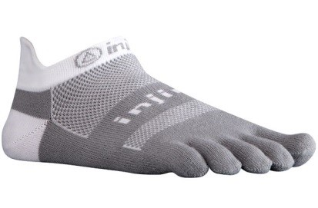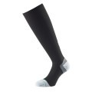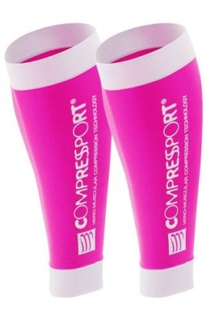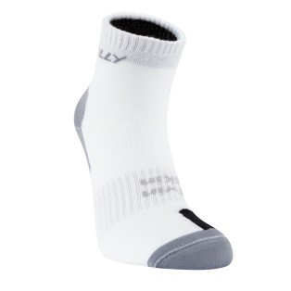

Other advice:
There are other things that can work with the right underwear to actually enhance its performance. One of the main enemies of runner comfort is clothing getting sweaty, this is why the wicking qualities of sports clothing is so crucial as Lynne suggests:
“For the first time ever I have awful chaffing from my back pack from Saturday so I can only conclude that I must have sweated a whole bunch!! 4 lovely large graze marks across my back that now itch cause they are getting better and this is with a camelbak might I hasten to add so not impressed”.
Ideally you should use a non-bio washing power or liquid and you should not add fabric conditioner to the wash as it spoils the wicking properties of the clothing. Having said this, given that we live in a hard water area, if you don’t put conditioner in with your socks they end up feeling like cardboard, which is not good for your feet! So you have to decide yourself what you want to do with socks! Other things that might help stop chafing in the longer races include: putting Vaseline, Body glide, Body lotion or chamois cream (used in cycling to prevent saddle sores) on problem areas including your feet, armpits where your vest might rub, under your bra, or knicker line. Some people say that Vaseline can damage or stain your clothing, but I have never had a problem with it myself.
Whilst this article uses the experiences of a number of our runners to discuss the issue of the ‘right’ underwear, if whatever you do, works for you, then it is the right underwear for you.
Jill J, with contributions by Jan, Linda, Lynne and Zoe.

Running Resolutions for 2016

We thought that it would be fun to see what types of goals members were setting themselves for 2016 ,and here are some inspiring replies.

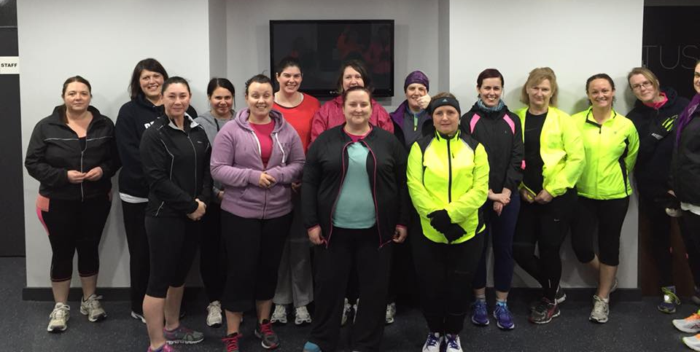

Here is a group of ladies with a great new year’s resolution- they have all started our 0- 5k course- fabulous way to start off the year!
Good luck to you all, and welcome to our lovely club!

Amanda:

Another year of going outside my comfort zone – good for the soul isn’t it???

Represent Great Britain at the World Duathlon Championships: Just to type those words makes my tummy go funny but this is what I am aiming at.
I will be doing the qualification event at Clumber Park on 19th March. The event is run 10K, cycle 40K (25 miles) then run 5K. I have done this event once before and did well which is what has prompted me to actually qualify and go through with it. Assuming I qualify I will then head off to Spain in June to represent Great Britain at the World Duathlon Championships. Imagine me doing that!
I will have to do some tough training to get myself up to scratch.

Thunder Run 24 – Team of 5: With Rachael, Sara, Sally and Debbie I hope to get the team into a prize winning position at the Thunder Run in July.
Lots of long stamina runs needed at a strong pace.

Hull Marathon: Do a full training programme and improve on my time.

Kate B:
Volunteer at Park Run.

Rachel W:

No 1 has to be THE MARATHON
I am still so pleased to have a place in London. I know it’s a dream for many runners and to have this fulfilled through our fab club is a real privilege for me.
Training has started in earnest now, so far so good, I am ticking the runs off one at a time and my main aim is to get to the 24th April fit and injury free so that I can complete the marathon as best I can.
Secretly in my head I’d like to complete it in a time that is around 4½ hours and closer to 4 hours than 5 but let’s keep that one quiet!!

No 2 is Half Marathons
My best ever half marathon time is 1.58, which was a few years ago at GNR. Since then I’ve had a little break and my times last year for both half marathons I did were around 2.04. I’d love to get back to running a sub 2 hour half this year

No 3 Champagne League
I loved taking part in this last year and would like to again this year if I can get a place. My resolution is to complete all races this year (I missed one last year) so I can at least come away with a t-shirt.

No 4 Rudolph Romp
Finally after at least 3 years of reccying (is that a word?) I completed the full 24 and a bit miles of the Rudolph Romp. Hopefully this year I’ll be back again and in a time quicker than last year (without that wind!)

And I think that will be enough to keep me out of mischief for the year!
Hope everyone at WHL has a super 2016 and stays fit and strong to achieve all their personal goals

Jan:

In terms of new year resolutions (running-related ones anyway!), I want to lose weight (at least half a stone) as I know that will help my speed and running style.
I also want to be smarter about my running and make every run count – that’s something I’m learning from Andy. So not just to ‘go out for a run’ but to make sure it’s either a speed session, a fast-paced run, a hilly session or a long run. I am convinced that doing more speed sessions is what makes the difference.
And of course another resolution is try and keep my daughter at bay!

Linda:
Run London Marathon 2016!

Anna:
Well- I have finally decided to try and up my distance to a half marathon- just because I would like to try. My furthest distance to date has been ten miles, so its within reach, but seems an awfully long way! I picked the North Lincs half because everyone has said how flat it is- that had better be true!
The easy bit was clicking "pay now", the hardest bit will be having the confidence to go for it. But, because of the amazing support in the club- I already have two training buddies which is wonderful- thank you!

This year I am also pinching an idea from Kate T, (and I think Linda may also do this,) - I have decided to keep a running diary of the year- just because it sounds interesting to do and to look back at.

Muddy Feet- Fab Runs

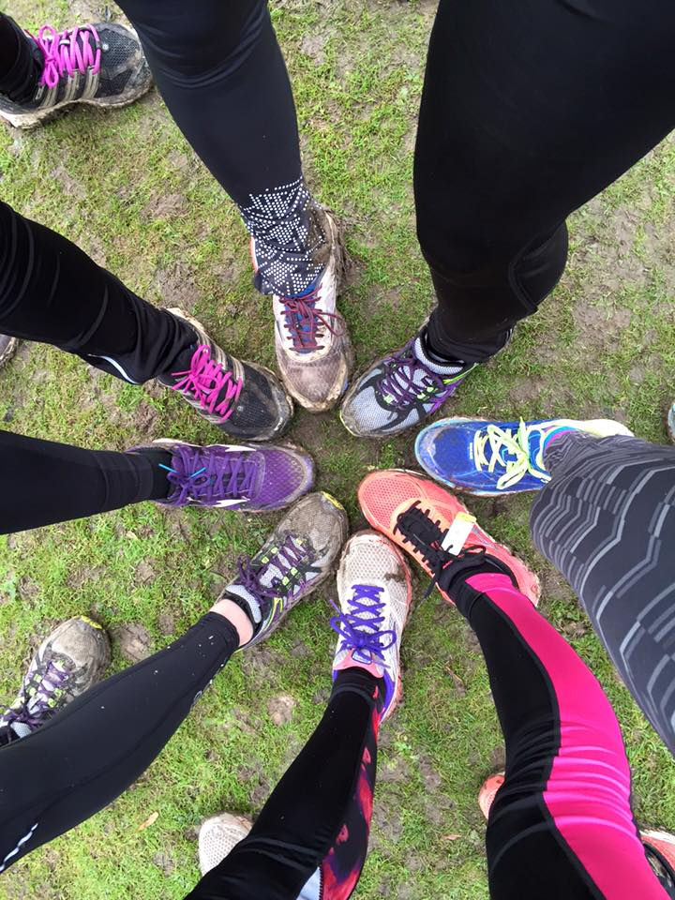

Recipe- Jermaine

Hi
Well in these winter months it is nice to have a few soup recipes.. A good soup helps warm you up when you come in off a long run. You can have with a chunk of bread 🍞
Cream of Butternut Squash
1 large onion
1 butternut squash
3 cloves of garlic
Tsp paprika
Ground black pepper
2 x vegetable oxo cubes
Approximately 50 ml single cream
Tsp of coconut oil (or any oil you like)
Method
Heat oil in a large pan
Peel & chop onion & garlic - fry on medium heat until the onions are clear. Peel & chop the butternut squash into large chunks. Place it in the pan with the onion & garlic and add the paprika fry on a low heat. Make 1 litre of stock with the two oxo cubes. Add to the pan and cook on a low heat for about 20 mins. Using a hand blender (or soup blender) bend the mixture then add the cream and pepper to taste.
I then halved the soup and added gorgonzola cheese on low heat (vegetarian version) and to the other half I chopped & fried some chorizo and added that. Both tasted delicious & were really filling.
Enjoy - Jermaine

2016 RACE DIARY
http://westhullladies.org.uk/races.htm

Free 5K time trial every Saturday 9am: Hull Parkrun or Peter Pan Parkrun

 | Date/Time | Event | Fee | Entry forms | Online entry

January 2016
 | 1st/10:30 | Cleethorpes New Year's Day 10K | £12 UKA/£14 | Online entries only | Online entry
 | 1st/11:00 | Beverley Lions New Year's Day Fun Run (3K, 6K and 10K) | £TBC | Entry Form | Postal entries or enter on the day
 | 17th/10:00 | Brass Monkey Half Marathon | Race Full | Race Full | Race Full
 | 24th/10:00 | Ferriby 10 Miles | £15.50 UKA/£17.50 | Online entries only | Online entry
February 2016
 | 21st/11:00 | Snake Lane 10 Mile | Race Full | Race Full | Race Full

Please remember to double check dates, times and entry fees with the official website or the entry form. Zx
Keep checking the website for new races and updates:

NOTE: Club Vests must be worn at any races you enter
under the West Hull Ladies running club name.

Kit Order Form

NEW STYLE VESTS are purchased direct from www.pbteamwear.co.uk
On website: click on Clubs, Athletics Club, West Hull Ladies RC
Pick your size, name you wish to have on the front and follow payment instructions

For all other purchases use this form.

FORENAME ___________________________________
SURNAME ___________________________________

ORDER - tick what you require and circle your size Price
- OLD STYLE VEST SIZE 10 12 £10.00 (useful for training)
- LONG SLEEVED SIZE 10 12 14 16 £18.50 £10.00 (useful for training)
- HOODIE SIZE XS S M L £20
- HOODIE with ZIP SIZE XS S M L £20
Note on size: M is approximately size 14

- BEANIE HAT £6.50
- PINLESS WHL NUMBER FASTENERS (set of 4) £3.00

DATE Ordered _______________
AMOUNT PAID _______________

Please transfer payments online with your name and marked as ‘Kit to:
Account: 63762742 Sort Code: 20 43 49

Or cheque payable to ‘West Hull Ladies RRC’, and write your name and ‘Kit’ on the back and give to Club Treasurer Linda Dodsworth, 110 The Stray, South Cave, E Yorkshire. HU15 2AL

Sign on receipt of goods _________________________________
DATE _______________

Please complete this form and email to diazmaria@btinternet.com
Thanks.
Maria Kit Officer

